**Energy and Environmental Technologies for Building Systems**

**Final Project**

**Silvia Cordieri**

**Lavinia Persico**

A medium-sized office building has been modelled through Sketch up 2016. The thermal load data, weather data and wall construction data have been rendered to the model via Open Studio 2.3.1. A parametric study has been conducted on the variation of wall construction and on the variation of glass thickness of the windows. Our based city is Bologna, but we did an energy simulation also in Catania and in Bratislava.

The building has been modelled with three stories with the dimension of 30x40x3 meters each.

The first floor and the third floor are composed by offices and stairs; the second floor is composed by two restrooms, a print room, a breakroom and stairs. Each wall has been modelled with 40% fenestration.

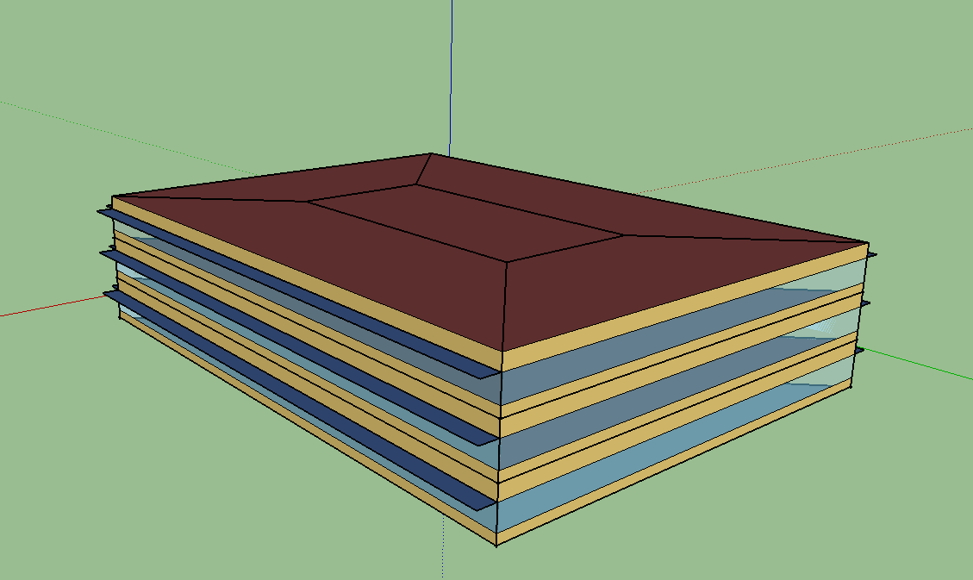

From the figure, it can be seen it has 6 different thermal zones.

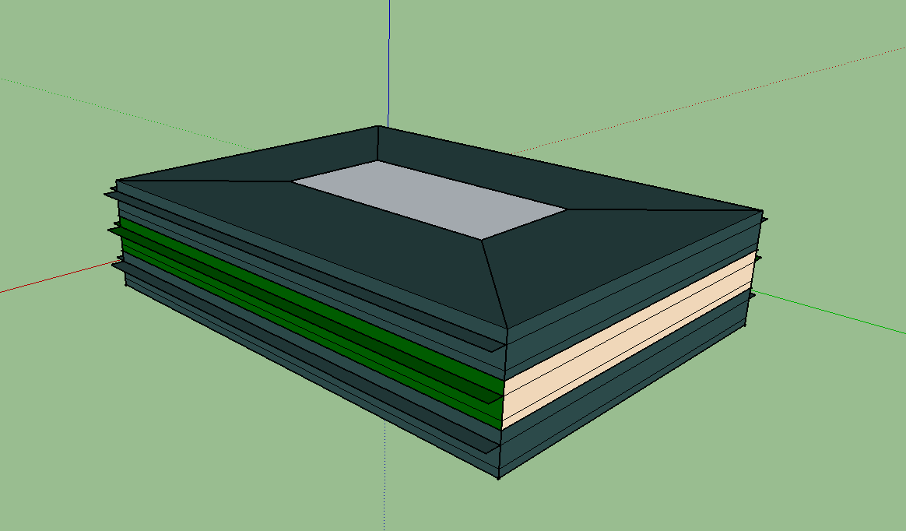

The building in the base case (for the wall and windows) is modelled in three different cities.

**🡪BOLOGNA**

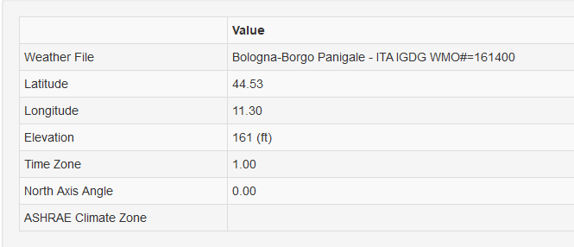

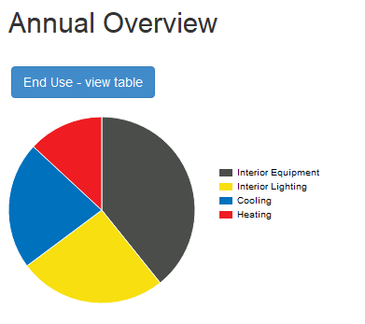

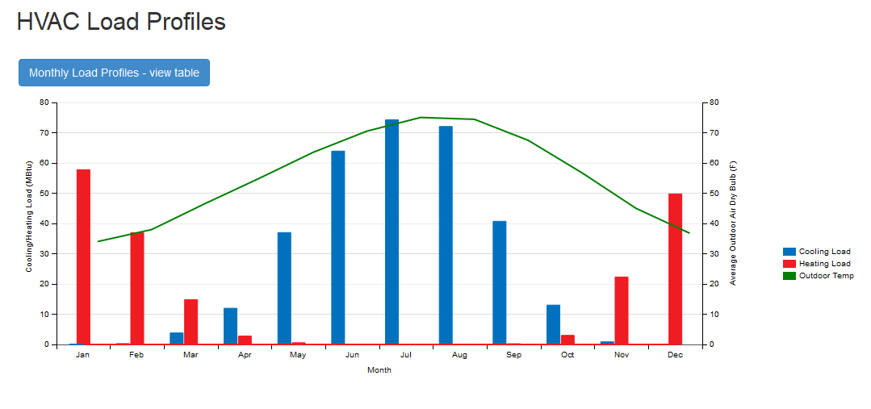

**🡪CATANIA**

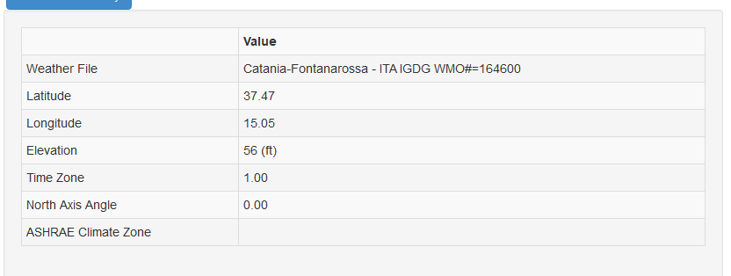

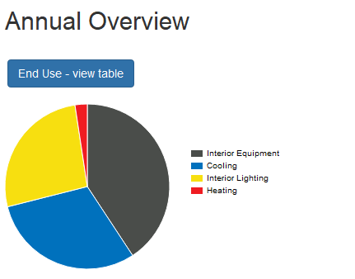

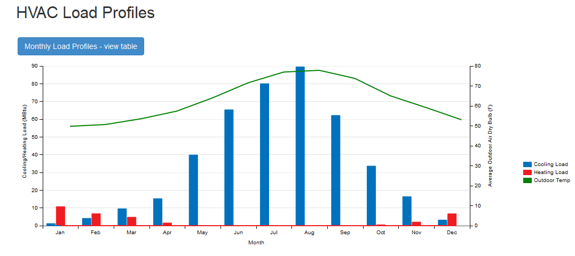

**🡪BRATISLAVA**

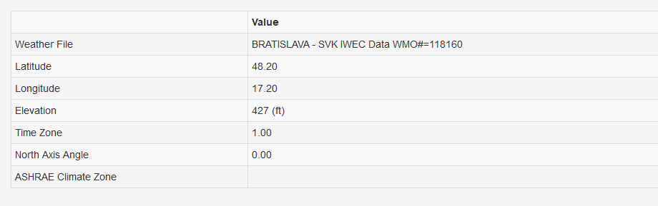

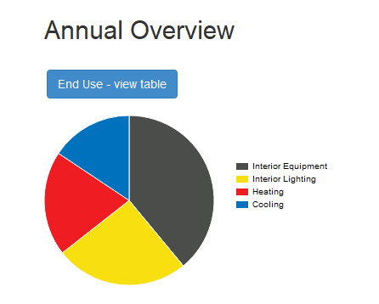

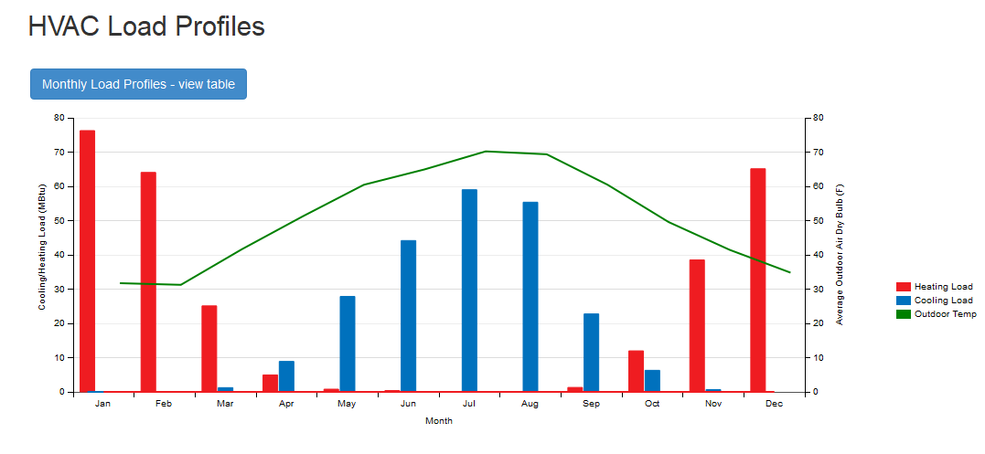

Now we change the wall composition with a better case and a worse case with respect to base case.

**WALL BASE CASE BETTER WALL WORSE WALL**

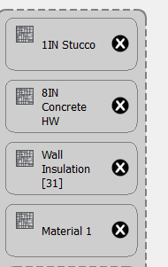 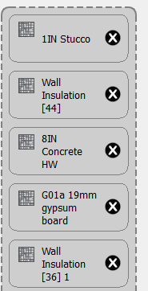 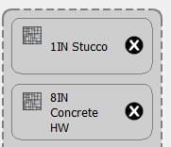

Now we change the glass thickness of the windows with a better case and a worse case with respect to base case.

**BASE CASE BETTER WINDOW WORSE WINDOW**

